Panelist Flow

* Dashboard

Dashboard Bar

Type: Container

Data:



Pie Chart (Global)

Type: Presentational

Data:



Statistics (Global)

Type: Presentational

Data:

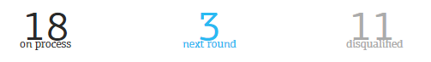

Dashboard Details(same for recruiter)

Type: Container

Data:

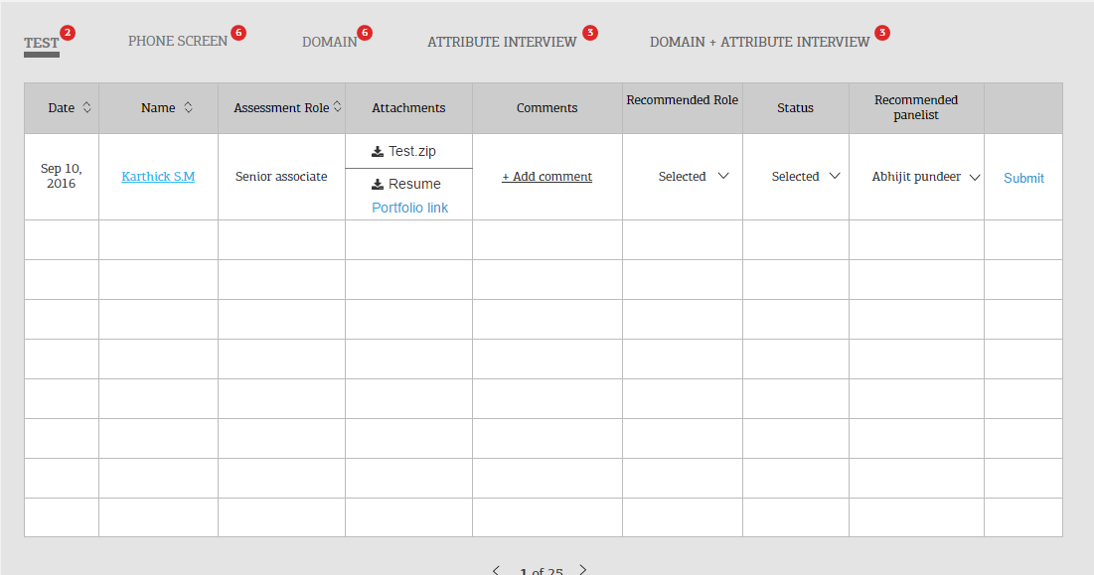

Navigation Tab List

Type: Container

Data:



Navigation Tab Item

Type: Presentational

Data:



Grid

Type: Container

Data:

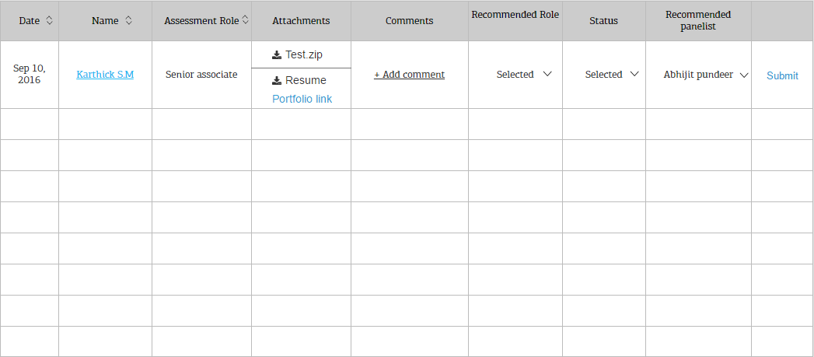

Grid Item

Type: Presentational

Data:



Grid Header

Type: Presentational

Data:

C:\Users\ksin68\Desktop\gridheader.PNG

Comment (Global)

Type: Presentational

Data:

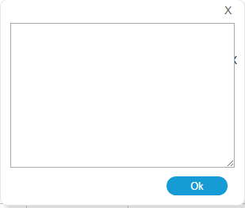

Submit Button (Global)

Type: Presentational

Data:



Dropdown (Global)

Type: Presentational

Data:



Pagination (Global)

Type: Presentational

Data:



* View Completed

*No New components, assemble page from previous components.*

* *Profile*

Candidate Info Card (Global)

Type: Presentational

Data:



Rating List (Global)

Type: Container

Data:

*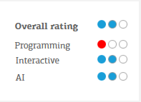*

Rating Item (Global)

Type: Presentational

Data:

**

* *Interview Round*

Timer

Type: Container

Data:

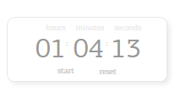

Interview Round Summary

Type: Presentational

Data:

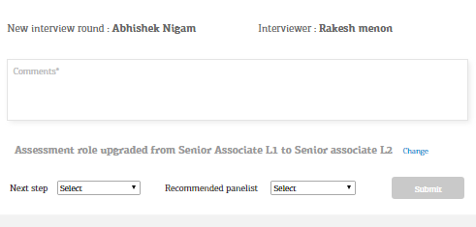

*Domain Round Question-*

*Type: CONTAINER*

*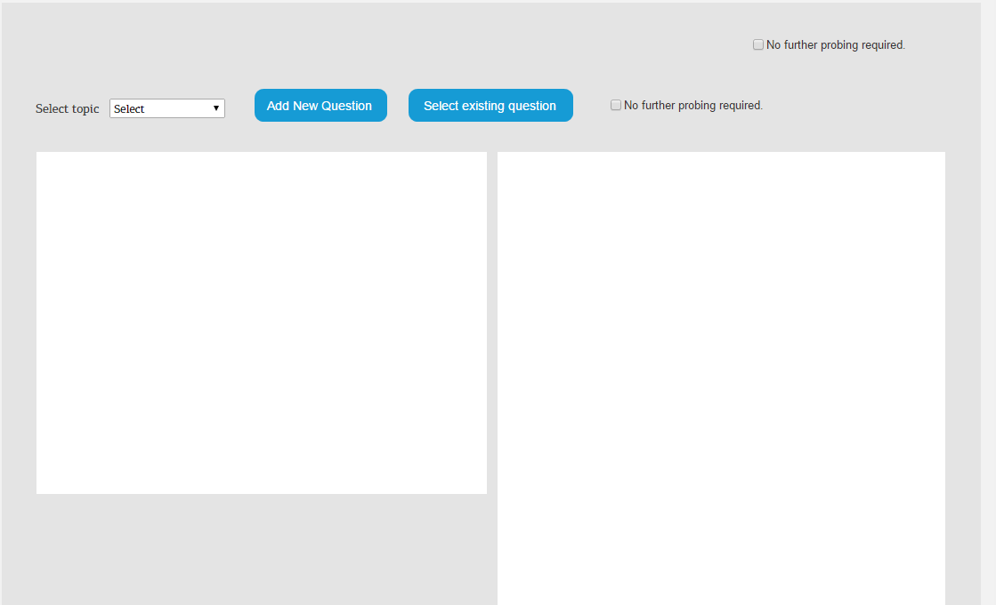*

Question Item

Type: Presentational

Data:

*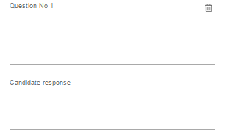*

Question List

Type: Presentational

Data:

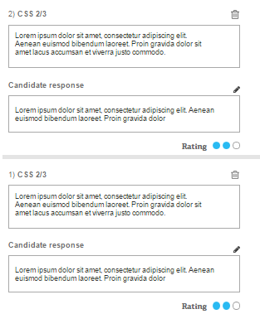

Existing Question Item

Type: Presentational

Data:



Existing Question List

Type: Container

Data:

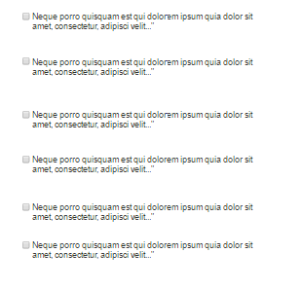

* *AI Test*

Interview Card

Type: Presentation

Data:

**

Interview Feedback

Type: Container

Data:

*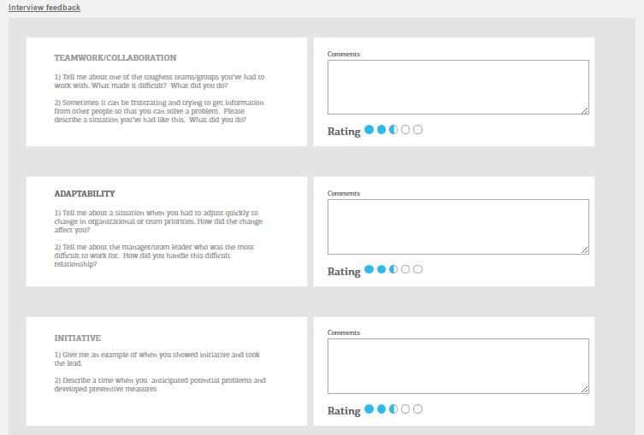*

Feedback Item

Type: Presentational

Data:

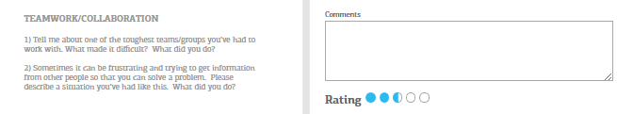

Feedback List

Type: Presentational

Data:

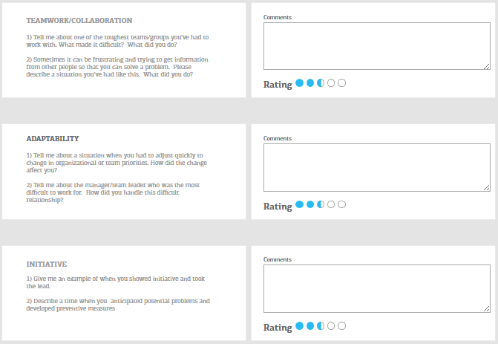

Sell Close Item

Type: Presentational

Data:



Sell Close List

Type: Presentational

Data:

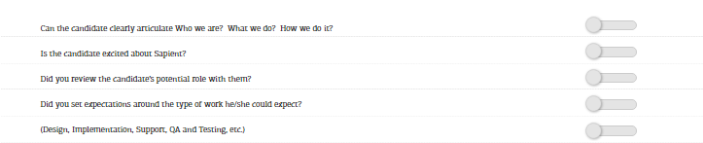

Role Upgrade

Type: Presentational

Data:

